An Intro to Spring HATEOAS

Spring boot Hateoas

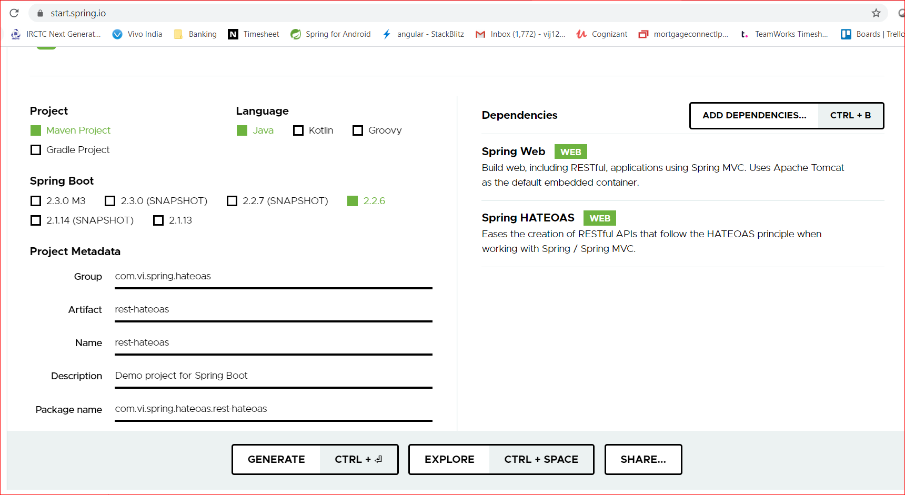

unZip and open the project in IDE

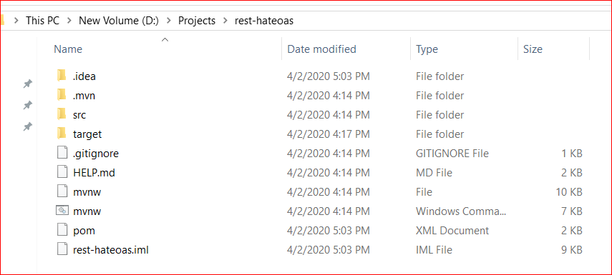

pom.xml

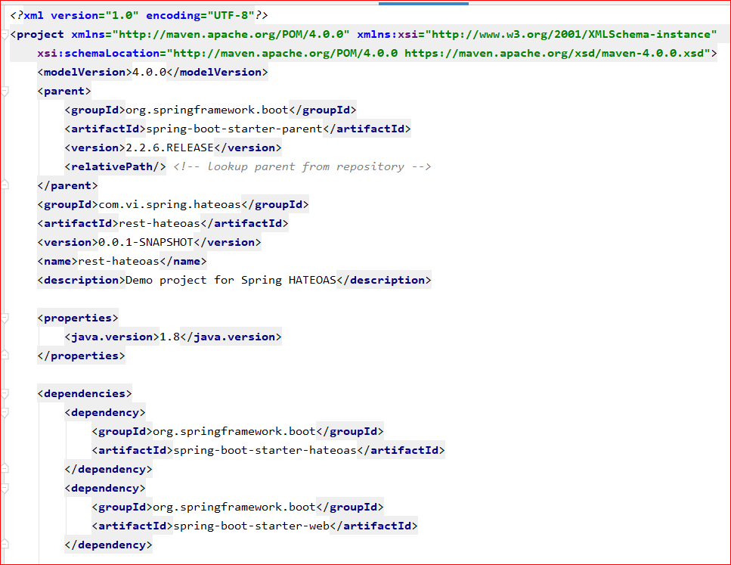

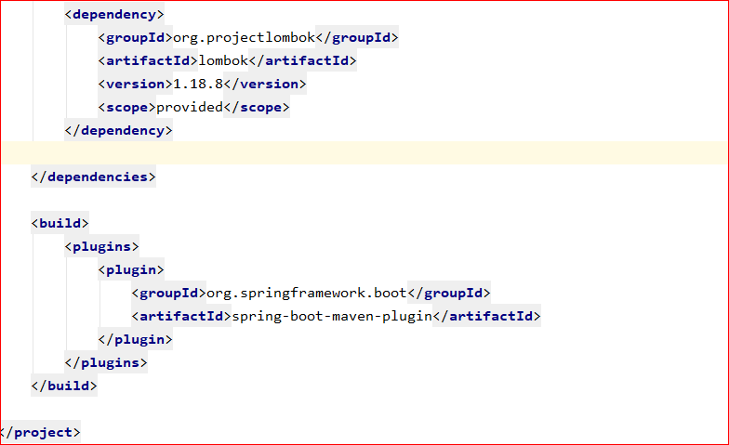

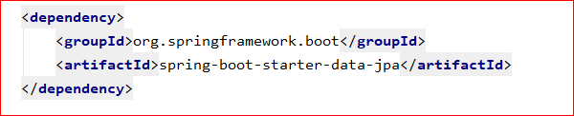

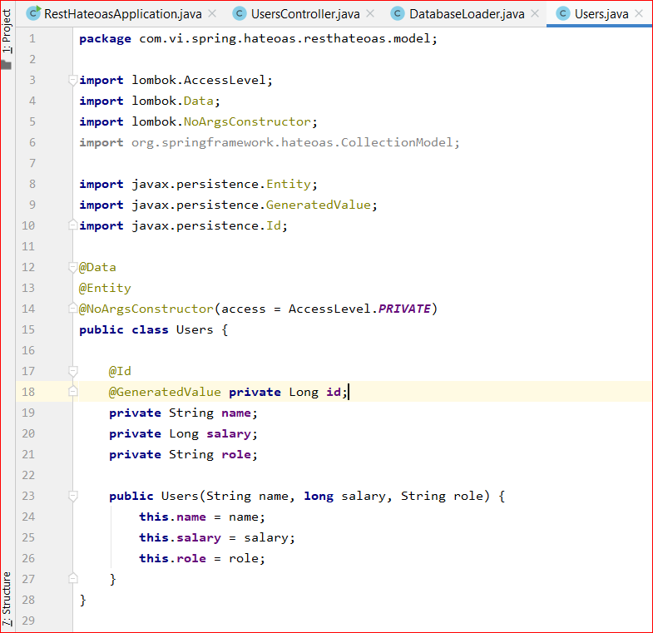

Create a embedded DB. H2 dadtabase. To load some pre data using spring boot.

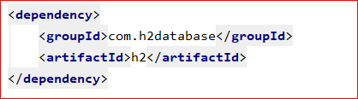

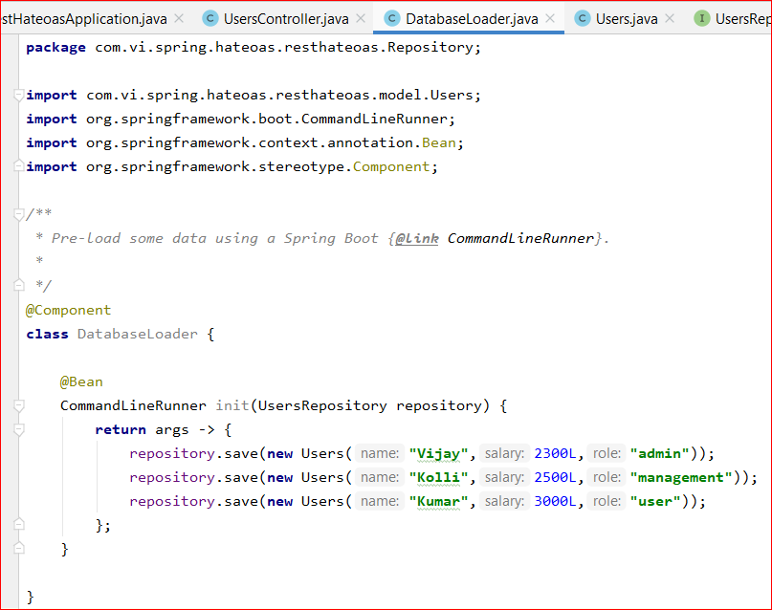

Create Repository to use build in methods like findAll, findOne etc..

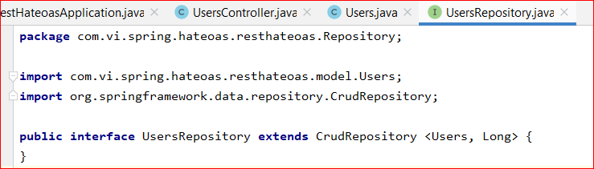

UserController

Hateoas using Collection Model

The links can be created using **WebMvcLinkBuilder**

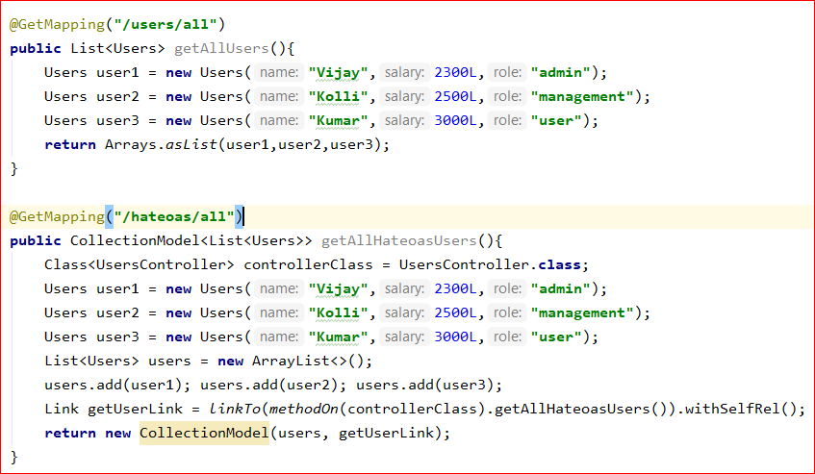

Entity Model : To create multiple links referencing the other api methods.

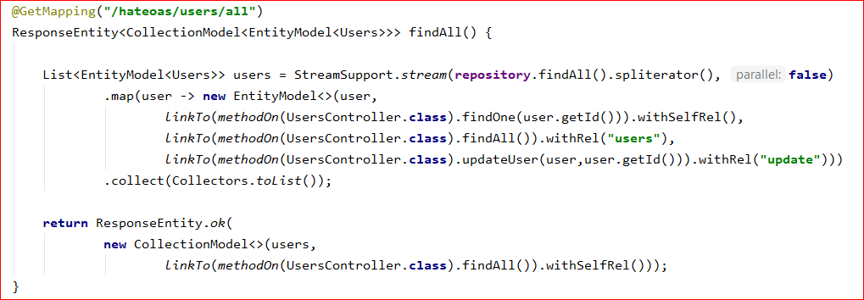

Api methods to add and update

